HACKER RANK (JAVA PROGRAMS)

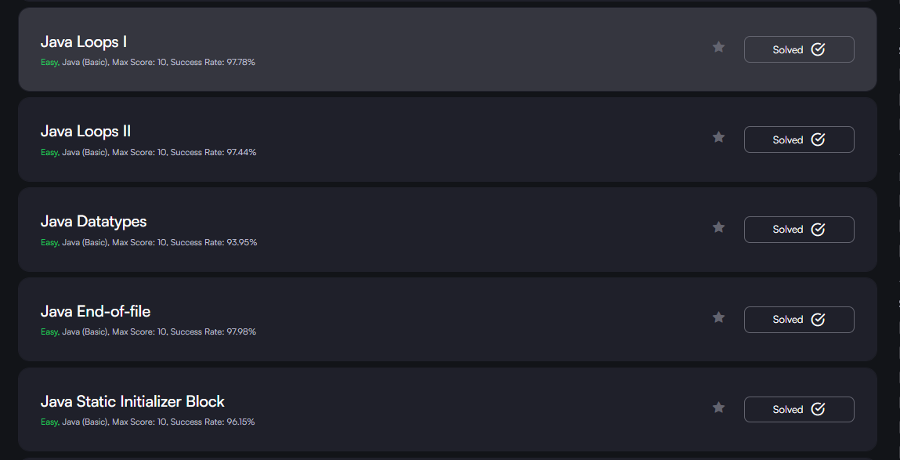

6 . java loops I

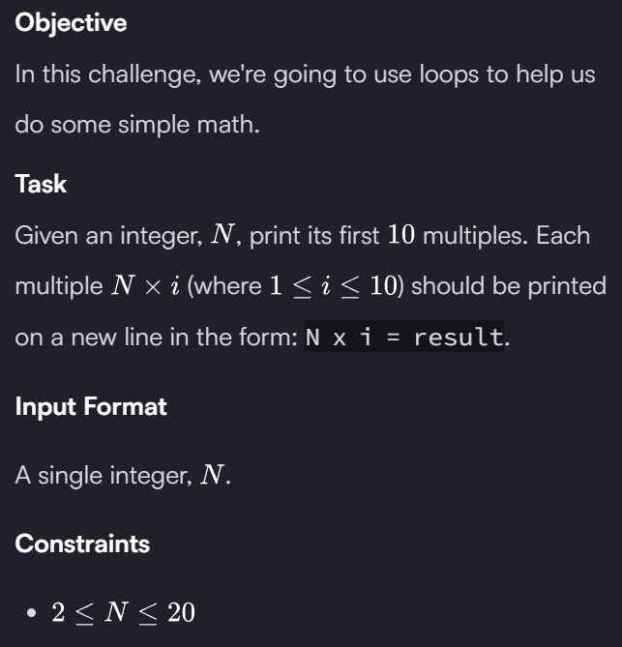
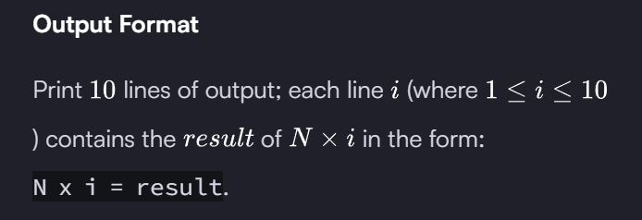
Sample Input
2
Sample Output
2 x 1 = 2
2 x 2 = 4
2 x 3 = 6
2 x 4 = 8
2 x 5 = 10
2 x 6 = 12
2 x 7 = 14
2 x 8 = 16
2 x 9 = 18
2 x 10 = 20

7 . Java Loops II
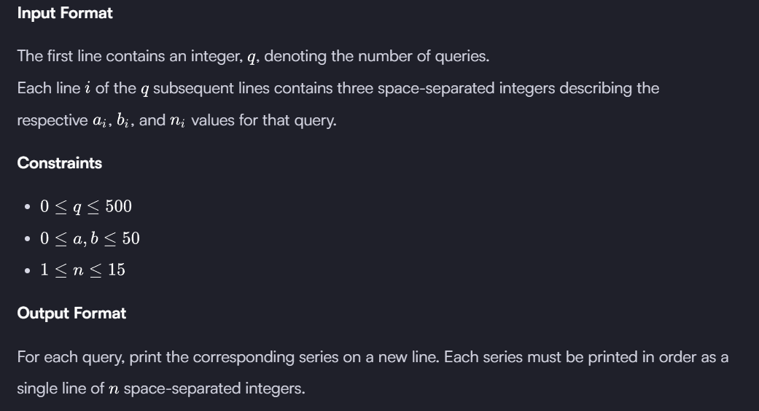
Sample Input
2
0 2 10
5 3 5
Sample Output
2 6 14 30 62 126 254 510 1022 2046
8 14 26 50 98
8. 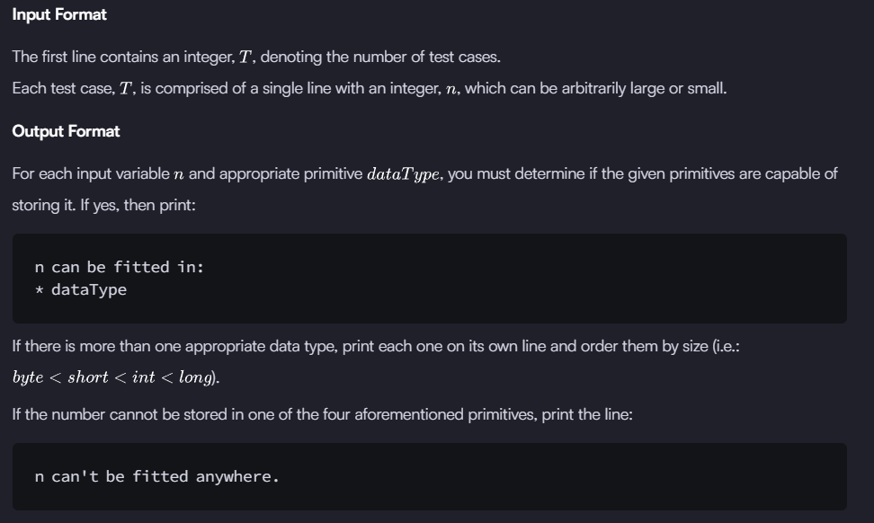
Sample Input
5
-150
150000
1500000000
213333333333333333333333333333333333
-100000000000000
Sample Output
-150 can be fitted in:
* short
* int
* long
150000 can be fitted in:
* int
* long
1500000000 can be fitted in:
* int
* long
213333333333333333333333333333333333 can't be fitted anywhere.
-100000000000000 can be fitted in:
* long

9 . 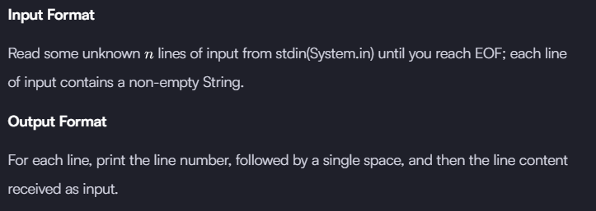
Sample Input
Hello world
I am a file
Read me until end-of-file.
Sample Output
1 Hello world
2 I am a file
3 Read me until end-of-file.

10 . 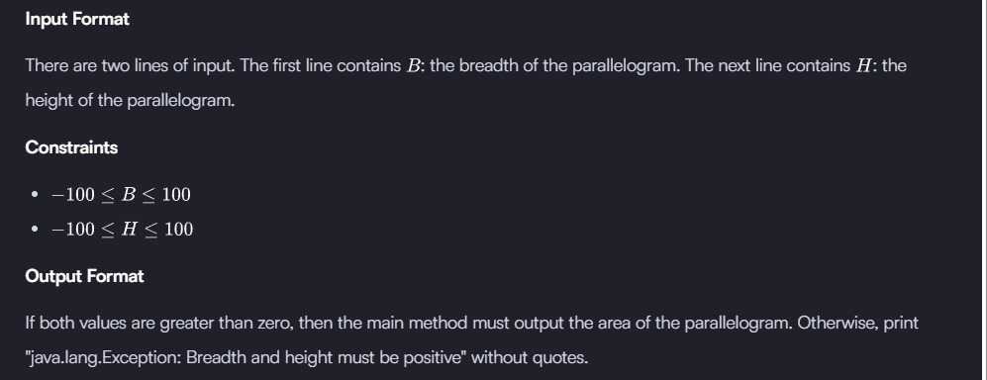
Sample input 1
1
3
Sample output 1
3
Sample input 2
-1
2
Sample output 2
java.lang.Exception: Breadth and height must be positive

